Open Strings

Grandpa G Daddy D Auntie A Baby E

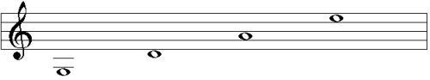
From left to right (also lowest to highest), the notes are: G, D, A, E.
The strings on the violin are also left to right (thickest to thinnest): G, D, A, E.

G D A E

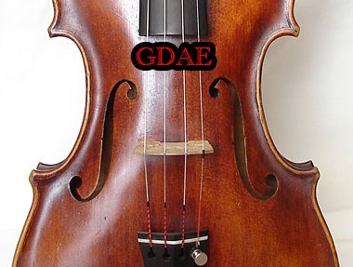
Low High

